Digital Signal Processing

Project: Text-To-Speech

Made by Phùng Gia Huy BI11-110

I. Definition:

Text-to-speech (TTS) is a type of assistive technology that reads digital text aloud. It’s sometimes called “read aloud” technology.

With a click of a button or the touch of a finger, TTS can take words on a computer or other digital device and convert them into audio. TTS is very helpful for kids who struggle with reading. But it can also help kids with writing and editing, and even focusing.

II. How it work?

TTS works with nearly every personal digital device, including computers, smartphones and tablets. All kinds of text files can be read aloud, including Word and Pages documents. Even online web pages can be read aloud.

The voice in TTS is computer-generated, and reading speed can usually be sped up or slowed down. Voice quality varies, but some voices sound human. There are even computer-generated voices that sound like children speaking.

Many TTS tools highlight words as they are read aloud. This allows kids to see text and hear it at the same time.

Some TTS tools also have a technology called optical character recognition (OCR). OCR allows TTS tools to read text aloud from images. For example, your child could take a photo of a street sign and have the words on the sign turned into audio.

III. Text-to-speech in python:

1. Modules:

from gtts import gTTS

from googletrans

import Translator

import numpy as np

import matplotlib.pyplot as plt

from scipy.fftpack import fft

from scipy.io.wavfile import read

import os

2. Codes:

- I have use 2 ways for Text-to-speech: By file that include text and input text

- In this project, i use 3 languages: English, French and Spanish

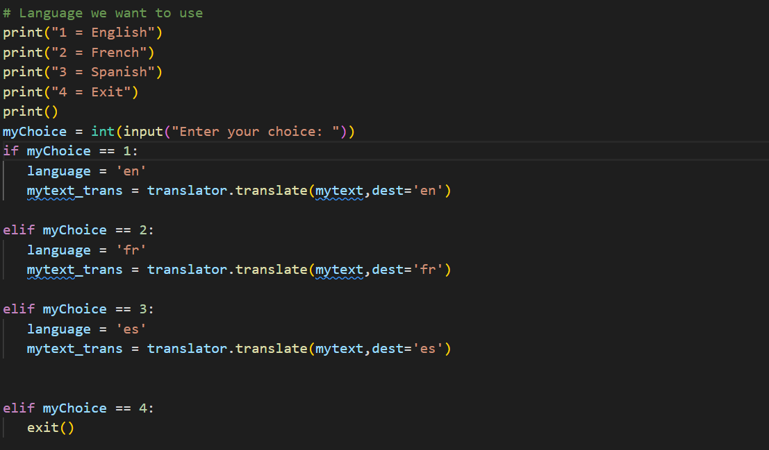

- For translator, i create an object:

translator = Translator()

+ Input text:

- Firstly, i try to input my text with:

mytext = input("Enter your text:")

- Then we choose 1 of 3 languages to output the speech with the voice’s language that you have chosen and finally we use:

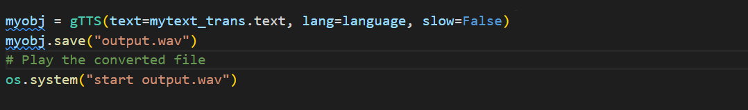

to have the wav file.

+ File that include text:

- Firstly, open and read file text:

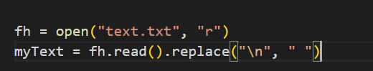

- Besides that I write a text or sentence in file text.txt. For example:

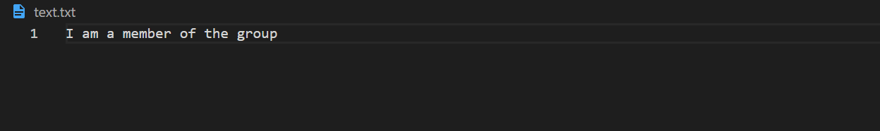

- Then we choose 1 of 3 languages to output the speech with the voice’s language that you have chosen and finally we use:

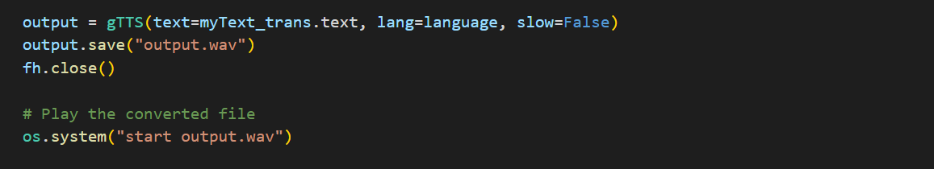

to have the wav file.

- After all, i try to plot audio signal, frequency domain

+ Audio signal:

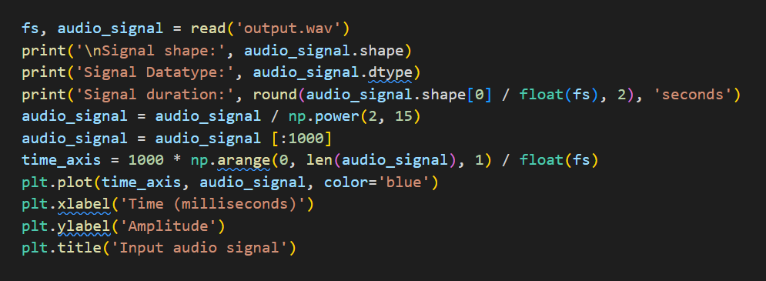

And the result as like:

(illustration)

+ Frequency domain:

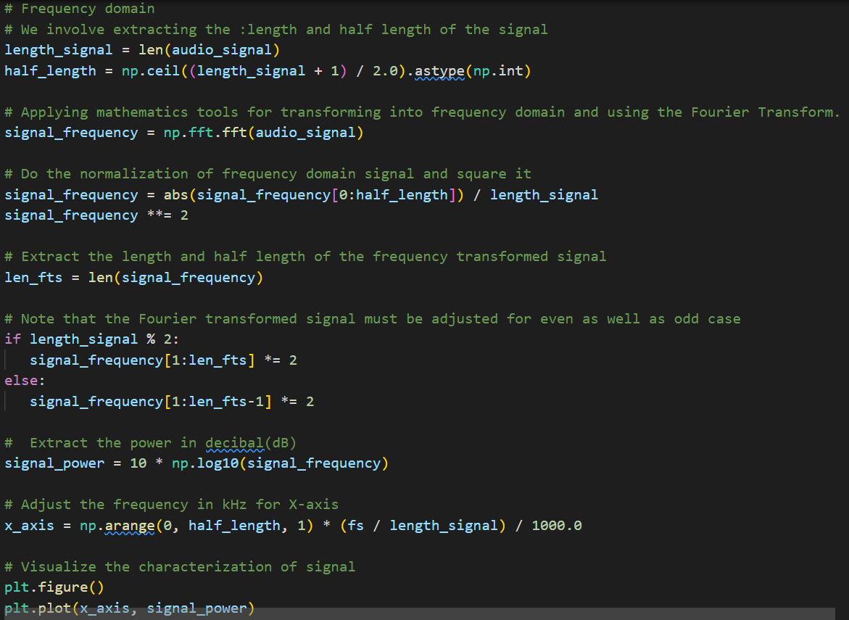

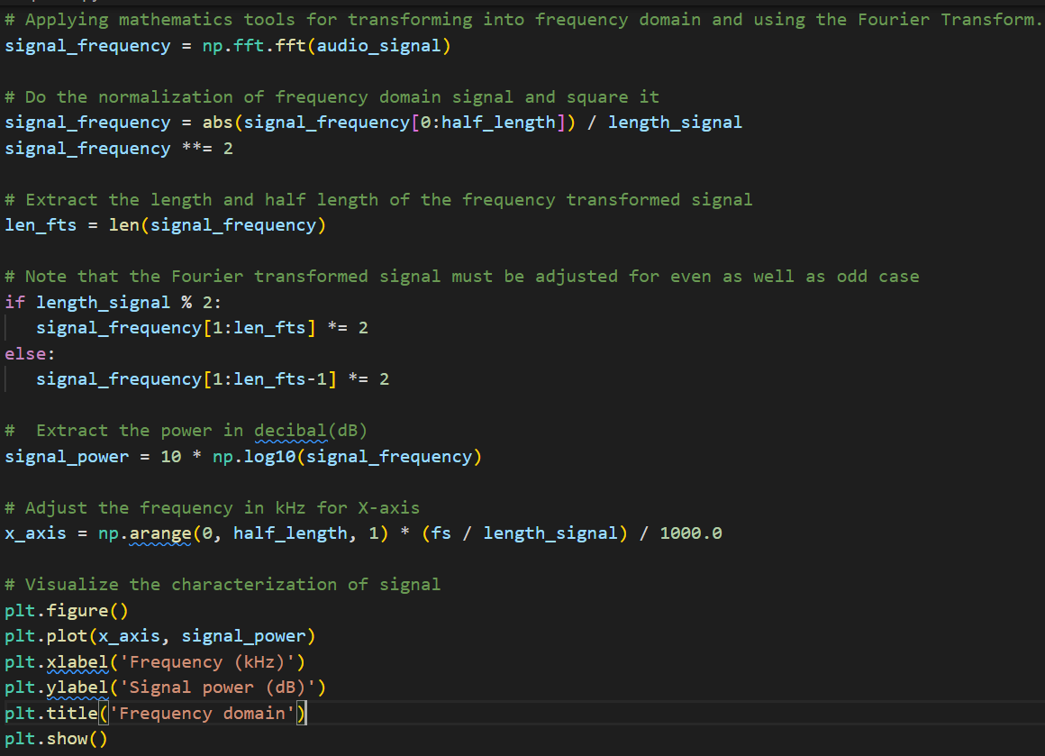

And the result as like:

(illustration but without title name)

IV. Some Text-to-speech tools:

* **Built-in text-to-speech:** Many devices have [built-in TTS tools](http://www.readingrockets.org/article/assistive-technology-s-built-mobile-devices). This includes desktop and laptop computers, smartphones and digital tablets and Chrome. Your child can use this TTS without purchasing special apps or software.
* **Web-based tools:** Some websites have TTS tools on-site. For instance, you can turn on our website’s “Reading Assist” tool, located in the lower left corner of your screen, to have this webpage read aloud. Also, kids with [dyslexia may qualify for a free Bookshare account](https://www.bookshare.org/signUpMember?utm_source=partner&utm_medium=learnmore&utm_campaign=understood) with digital books that can be read with TTS. There are also [free TTS tools available online](https://www.understood.org/en/school-learning/assistive-technology/finding-an-assistive-technology/free-assistive-technology-tools-on-the-web).
* **Text-to-speech apps:** Kids can also download TTS apps on smartphones and digital tablets. These apps often have special features like text highlighting in different colors and OCR. Some examples include Voice Dream Reader, Claro ScanPen and Office Lens.
* **Chrome tools:** Chrome is a relatively new platform with several TTS tools. These include Read&Write for Google Chrome and Snap&Read Universal. You can use these tools on a Chromebook or any computer with the Chrome browser. See more [Chrome tools to help with reading](https://www.understood.org/en/school-learning/assistive-technology/finding-an-assistive-technology/6-chrome-tools-for-kids-with-reading-issues).
* **Text-to-speech software programs:** There are also several literacy software programs for desktop and laptop computers. In addition to other reading and writing tools, many of these programs have TTS. Examples include Kurzweil 3000, ClaroRead and Read&Write. Microsoft’s Immersive Reader tool also has TTS. It can be found in programs like OneNote and Word. See more examples of [software for kids with reading issues](https://www.understood.org/en/school-learning/assistive-technology/finding-an-assistive-technology/software-programs-for-kids-with-reading-issues).